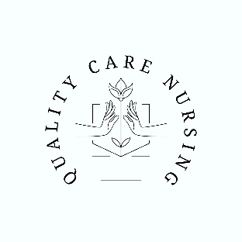

Physical Form
Quality Care Nursing
Health Examination
Nurse Aide Course
To be completed by applicant:

Name:_______________________________________________________________________________

Address:_____________________________________________________________________________

Phone:________________________________________________________________________________

To be completed by health care provider:
- Two-step Tuberculin Test- PPD required
#1. Date Administered: __________ Date Read:___________

Results: _________ Read By: ___________

Second PPD is to be administered one (1) week after first PPD is read but no longer than 21 days.
#2. Date Administered: __________ Date Read:___________

Results: _________ Read By: ___________

#3. If an IGRA was processed or Chest x-ray was obtained, a copy of the results is attached.

Yes, No Applicant is able to perform the duties of a nursing assistant.

Yes No I certify that this applicant was examined and believe them to be free of communicable
Disease in a communicable state.

Yes, No Applicant is free from any restriction or limitations. If no, briefly explain the restriction
or limitation (applicant is free from communicable disease in a communicable state.)
Provider Signature: ____________________________________________________________________

Provider Title: ______________________________________________________(MD, DO, PA, CRNP)

Address:_____________________________________________________________________________

Phone:___________________________________ Date:__________________________________

